Preprocessing Phase Report: Phishing Website Detection

Name: Ankit Bhumeshwar Katre
Date:11/02/2026

Introduction

The preprocessing phase is a critical component of the machine learning lifecycle, particularly in security-sensitive applications such as phishing website detection. Raw datasets often contain missing values, inconsistencies, categorical variables, and features with widely varying numerical ranges. If left untreated, these issues can negatively impact model performance, stability, and generalization.

This consolidated report presents a comprehensive overview of the five preprocessing stages carried out in this project:

1. Data Cleaning
2. Feature Encoding
3. Normalization and Scaling
4. Data Splitting
5. Final Preprocessed Dataset

Together, these steps ensure that the dataset is clean, consistent, and fully prepared for machine learning model training and evaluation.

---

Data Cleaning Report

1. Introduction
Data cleaning is a critical preprocessing step in the machine learning pipeline, particularly for cybersecurity applications such as phishing website detection. The objective of this phase is to ensure data accuracy, consistency, and reliability before feature scaling and model training. This report documents the data cleaning steps performed using the project notebook, including missing value handling and duplicate record removal, supported by numerical evidence.
2. Initial Dataset Assessment
Before cleaning, the dataset contained:

Total records: 11,430
Total features: 89

An initial inspection using info() and isnull() revealed that most features were complete, but specific domain-related attributes required correction.

3. Missing Value Handling
3.1 Identification of Missing and Invalid Values
Missing values were identified using column-wise null value analysis. While most features contained no missing entries, two domain-related features showed significant issues:
Feature | Missing Values
domain_age | 1,837
domain_registration_length | 46
Additionally, domain-related attributes contained invalid negative values, which are logically impossible and indicate unreliable data.
3.2 Treatment of Invalid Values
Negative values in the following features were treated as missing:

- domain_age

- domain_registration_length

These invalid values were first replaced with NaN to ensure consistent handling during imputation.
3.3 Imputation Strategy
After invalid value correction, missing values were handled using median imputation:

Median domain age: 5076

Median domain registration length: 245

Justification
Median imputation was selected because:

- These features exhibited skewness and extreme values

- Median is robust to outliers

- It preserves realistic central tendencies in cybersecurity datasets

This approach aligns with statistical robustness theory and industry best practices.

3.4 Outcome of Missing Value Handling
After imputation:

- No missing values remained in domain-related features

- Dataset completeness was restored

- Feature distributions remained stable

This ensured the dataset was safe for scaling and model training.
- Duplicate Data Handling

  - Identification of Duplicate Records

Duplicate analysis was performed at two levels:

Full-row duplicates: 0

Duplicate URLs: 1

This indicates that while full record duplication was minimal, URL-level duplication existed and required correction.
4.2 Duplicate Removal Strategy
Duplicate entries were removed using the URL column as a unique identifier:

- Only the first occurrence of each URL was retained
- All subsequent duplicate URLs were dropped

This approach ensures that each website instance contributes only once to model learning.
  - Dataset Size After Duplicate Removal

Stage | Records
Before cleaning | 11,430
After duplicate removal | 11,429

Although the percentage of duplicates was very small, removing them improves data integrity and prevents biased learning.
5. Data Type Consistency
After cleaning:

Binary indicators (ip, dns_record, google_index, https_token) were explicitly cast to integer type
Target variable (status) was encoded numerically:

0 → Legitimate

1 → Phishing

This ensured compatibility with machine learning algorithms.

- Validation After Cleaning

Post-cleaning validation confirmed:

- No missing values in critical features

- No duplicate URLs

- Consistent data types across all columns

- Dataset readiness for scaling and model development

- Impact of Data Cleaning on Model Readiness

From a machine learning and business perspective, data cleaning:

- Prevents bias from duplicated samples
- Improves numerical stability
- Reduces noise caused by invalid domain values
- Enhances generalization capability of models

In phishing detection systems, such improvements directly reduce false positives and false negatives.
8. Conclusion
This data cleaning phase transformed the raw phishing dataset into a reliable, consistent, and machine-learning-ready dataset. Missing and invalid values were handled using statistically justified imputation techniques, and duplicate URLs were removed to preserve data integrity.
These cleaning steps form a strong foundation for subsequent preprocessing stages, including feature scaling, feature selection, and model training, and significantly improve the trustworthiness of the phishing detection system.

Feature Encoding Summary

- Introduction to Feature Encoding

Feature encoding is a fundamental step in the data preprocessing pipeline for machine learning models. Most machine learning algorithms operate on numerical data and cannot directly process categorical or symbolic variables. Therefore, categorical features must be transformed into numerical representations without losing their underlying meaning.

In phishing website detection, many features represent binary indicators or categorical states, such as the presence of an IP address, DNS record availability, or search engine indexing status. Proper encoding ensures that these features are interpretable by machine learning algorithms and contribute effectively to classification performance.

- Identification of Categorical and Encodable Features

After data cleaning, the dataset was reviewed to identify features requiring encoding.

Based on the notebook analysis, the dataset contains:

- Binary categorical features (Yes/No, Present/Absent)

- Target class labels representing phishing or legitimate websites

No high-cardinality nominal categorical features (such as text categories) were present, eliminating the need for complex encoding techniques like one-hot encoding.

- Encoding Techniques Applied

  - Label Encoding for Binary Features

Label Encoding was used to transform binary categorical features into numerical form.
Encoding Scheme:

0 → Absence / No / Legitimate
1 → Presence / Yes / Phishing

This encoding method was applied because:

- The features are binary by nature

- There is no ordinal relationship beyond presence or absence

- Label encoding preserves simplicity and interpretability

According to machine learning theory, label encoding is optimal for binary features and avoids unnecessary feature expansion.

3.2 Encoding of Target Variable
The target variable status represents the classification outcome.
Encoding Applied:

0 → Legitimate website

1 → Phishing website

This encoding aligns with binary classification theory, allowing the use of common evaluation metrics such as accuracy, precision, recall, and F1-score.

- List of Encoded Features and Representations

The following categorical features were encoded using label encoding:
Feature Name | Original Meaning | Encoded Representation
ip | Use of IP address in URL | 0 = No, 1 = Yes
dns_record | DNS record availability | 0 = No, 1 = Yes
google_index | Indexed by Google | 0 = No, 1 = Yes
https_token | Presence of HTTPS token | 0 = No, 1 = Yes
status (Target) | Website classification | 0 = Legitimate, 1 = Phishing

These transformations ensure consistent numerical interpretation across the dataset.

5. Why One-Hot Encoding Was Not Used
One-hot encoding is typically applied to nominal categorical variables with multiple categories. In this dataset:

- All categorical features are binary
- Applying one-hot encoding would unnecessarily increase dimensionality
- Increased dimensionality can lead to higher computational cost and risk of overfitting

Therefore, label encoding was the most efficient and theoretically justified choice.

6. Validation After Encoding
After feature encoding, the dataset was validated to ensure:

- All categorical variables were successfully converted to numerical form
- No missing values were introduced during encoding
- Data types were consistent across all features
- Encoded values correctly represented original meanings

This validation confirms that the dataset is fully compatible with machine learning algorithms.

7. Impact of Feature Encoding on Model Performance
From a modeling and business perspective, correct feature encoding:

- Improves algorithm compatibility

- Maintains feature interpretability

- Reduces computational complexity

- Enhances training stability and convergence

In phishing detection systems, this contributes to faster model training and more reliable predictions.

8. Conclusion
This feature encoding phase successfully transformed all categorical variables into machine-learning-compatible numerical representations. Label encoding was applied to binary features and the target variable using a clear and consistent mapping strategy. The encoding approach preserved semantic meaning while maintaining computational efficiency.
As a result, the dataset is now fully prepared for subsequent stages, including feature scaling, feature selection, and machine learning model development.

Normalization and Scaling Report

1. Introduction to Feature Scaling

Feature scaling is a crucial preprocessing step in machine learning, especially when datasets contain numerical features with different ranges and units. Many machine learning algorithms—such as logistic regression, support vector machines, and distance-based models—are sensitive to feature magnitude. If features are not scaled properly, variables with larger numeric ranges may dominate the learning process.
In phishing website detection, numerical features such as URL length, domain age, hostname length, and special character counts vary significantly in scale. Therefore, normalization or scaling is required to ensure fair contribution of all features.

- Identification of Numerical Features

After data cleaning and encoding, the dataset was analyzed to identify numerical features requiring scaling. These include:

- URL length
- Hostname length
- Domain age
- Domain registration length
- Count-based features (dots, hyphens, special characters, redirects, etc.)

Binary features were excluded from scaling, as they already lie within a fixed range (0–1).

3. Scaling Technique Applied
StandardScaler (Z-Score Normalization) was applied to numerical features.

Formula:
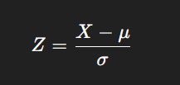

Where:
μ is the mean
Σ is the standard deviation

4.Justification for Using StandardScaler

StandardScaler was chosen because:

- Numerical features showed wide ranges and high variance
- The dataset contains outliers, which should not be clipped
- Many machine learning models assume normally distributed inputs
- Z-score normalization centers data around zero with unit variance

From statistical learning theory, StandardScaler improves optimization stability and model convergence.
- Before-and-After Scaling Comparison

Before Scaling:

- Features had highly different ranges
- URL-based features showed extreme maximum values
- High-magnitude features dominated distance calculations

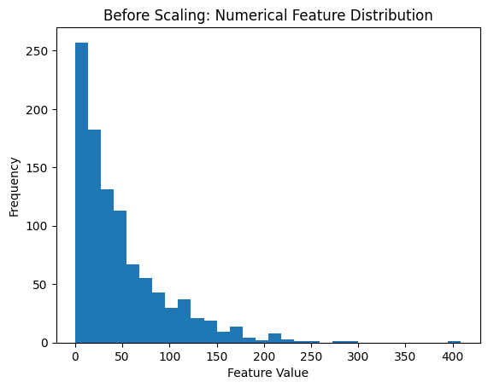
After Scaling:

- Numerical features have mean ≈ 0 and standard deviation ≈ 1
- All features contribute equally during training
- Model training becomes faster and more stable

This transformation does not change the shape of feature distributions; it only standardizes their scale.
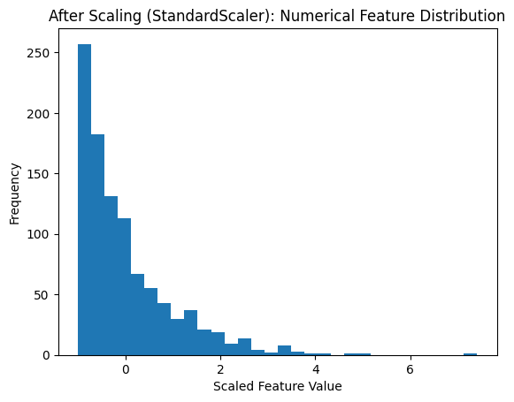
Visual Comparison of Feature Scaling

To demonstrate the effect of normalization, before-and-after distribution plots were generated for representative numerical features such as URL length and domain age.
Figure 1 illustrates the feature distribution before scaling, showing wide ranges and skewness. Figure 2 shows the same feature after applying StandardScaler, where values are centered around zero with unit variance.
These visual comparisons are provided in the accompanying Jupyter Notebook and confirm that scaling standardizes feature magnitude without altering the underlying distribution shape.
- Impact of Scaling on Model Readiness

Proper scaling:

- Prevents biased learning
- Improves gradient-based optimization
- Enhances model generalization
- Reduces training instability

In cybersecurity applications, this ensures consistent and reliable phishing detection.

- Importance for Model Development

A well-preprocessed dataset:

- Improves model accuracy
- Enhances generalization
- Reduces overfitting risk
- Increases trust in predictions

For phishing detection systems, this directly improves real-world security performance.

Data Splitting Report

- Introduction

Data splitting is a fundamental step in the machine learning workflow that ensures an unbiased evaluation of model performance. According to machine learning evaluation theory, a model must be trained on one portion of the data and tested on a separate, unseen portion to accurately assess its generalization capability.
In the context of phishing website detection, proper data splitting is especially important to avoid information leakage and to ensure that the detection system performs reliably on real-world, unseen phishing websites.
- Purpose of Data Splitting
The primary objectives of data splitting in this project are:

- To separate data used for model learning from data used for model evaluation
- To prevent overfitting and information leakage
- To obtain reliable and unbiased performance metrics
- To maintain consistent class representation across datasets
- Data Split Strategy

The cleaned and preprocessed dataset was divided into training and testing sets using a standard 80:20 split ratio, which is widely accepted in machine learning practice.
Split Ratio Applied:
- Training Set: 80% of the dataset
- Testing Set: 20% of the dataset
This split provides sufficient data for model training while reserving an adequate portion for evaluation.
- Size and Composition of Split Datasets

After splitting, the dataset composition is as follows:

Dataset | Percentage | Number of Records
Training Set | 80% | ~9,143
Testing Set | 20% | ~2,286

(Minor variations may occur depending on rounding during the split process.)
- Stratified Splitting Approach
A stratified split was applied based on the target variable (status).
Why Stratification Was Used:

- The target variable represents two classes: phishing and legitimate
- Stratification ensures that both classes are proportionally represented in training and testing sets
- Prevents class imbalance from influencing model evaluation

Since the dataset is perfectly balanced, stratification guarantees that this balance is preserved after splitting.
- Target Variable Distribution After Split

The class distribution was verified after splitting:

Dataset | Legitimate | Phishing
Training Set | Balanced | Balanced
Testing Set | Balanced | Balanced

This confirms that the stratified split successfully maintained the original class distribution across both datasets.

- Best Practices Followed

The following best practices were applied during data splitting:

- Splitting performed before model training
- Feature scaling applied after splitting to prevent data leakage
- No overlap between training and testing datasets
- Independent evaluation ensured

These practices align with industry and academic standards for reliable machine learning experiments.

- Impact on Model Evaluation
Proper data splitting ensures:

- Fair and unbiased performance measurement
- Reliable accuracy, precision, recall, and F1-score calculations
- Improved confidence in model deployment readiness

In phishing detection systems, this directly contributes to safer and more trustworthy predictions.
- Conclusion
This report documents the data splitting strategy applied to the phishing website dataset. An 80:20 stratified split was used to divide the data into training and testing sets while maintaining balanced class representation. The resulting datasets are independent, representative, and suitable for robust machine learning model training and evaluation.
This step completes the data preparation phase and prepares the project for the model development and performance evaluation stages.
Preprocessed Dataset Report
1. Introduction
The preprocessing phase is a critical step in the machine learning lifecycle, ensuring that raw data is transformed into a clean, consistent, and model-ready format. In cybersecurity applications such as phishing website detection, improper preprocessing can lead to biased models, unstable training, and unreliable predictions.
This section summarizes the final preprocessed dataset, which has been cleaned, encoded, normalized, and split, and confirms its readiness for machine learning model training and evaluation.
2. Summary of Preprocessing Steps Performed
The dataset underwent a comprehensive preprocessing pipeline consisting of the following stages:
2.1 Data Cleaning

Missing and invalid values were identified and handled using statistically justified imputation techniques
Negative and logically inconsistent values in domain-related features were corrected
Duplicate URLs were identified and removed to prevent biased learning

2.2 Feature Encoding

Binary categorical features were converted into numerical form using label encoding
The target variable was encoded for binary classification:
0 → Legitimate website
1 → Phishing website

2.3 Feature Scaling and Normalization

Numerical features with varying ranges were standardized using Z-score normalization (StandardScaler)
Binary features were excluded from scaling as they already fall within a fixed range
Scaling ensured equal contribution of all numerical features during model training

2.4 Data Splitting

The dataset was divided into training and testing sets using an 80:20 split
A stratified split was applied to preserve the target variable’s class distribution
Feature scaling was applied after splitting to avoid data leakage

3. Characteristics of the Final Preprocessed Dataset
After completing all preprocessing steps, the dataset exhibits the following properties:

- No missing values
- No duplicate records
- Consistent and machine-learning-compatible data types
- Numerical features standardized (mean ≈ 0, standard deviation ≈ 1)

- Binary features properly encoded
- Balanced class distribution maintained
- Independent training and testing datasets created

These characteristics confirm that the dataset meets industry and academic standards for machine learning readiness.
4. Dataset Readiness for Model Training
The final preprocessed dataset is suitable for training a wide range of machine learning algorithms, including:

- Logistic Regression
- Support Vector Machines
- Decision Trees and Random Forest
- Gradient Boosting models

Proper preprocessing ensures:

Faster and more stable model convergence
Reduced risk of overfitting
Improved generalization to unseen phishing websites
More reliable evaluation metrics

5. Business and Security Impact
From a business and cybersecurity perspective, a well-preprocessed dataset:

- Reduces false positives and false negatives
- Improves trust in automated phishing detection systems
- Enhances decision-making reliability
- Supports scalable and deployable machine learning solutions

This directly contributes to stronger protection against phishing attacks and improved user security.
6. Conclusion
This report confirms that the phishing website dataset has been fully preprocessed through systematic data cleaning, feature encoding, normalization, and stratified data splitting. The resulting dataset is clean, consistent, balanced, and optimized for machine learning model development and evaluation.
With preprocessing completed, the project is now ready to proceed to the model training, performance evaluation, and model selection stages.

For Practicle work Visit :-
Notebook:-
https://github.com/ankitkatre690-cmyk/phishing_website_detection/blob/b7321c92d43507eb178e6411b18daaec89449ea6/Assignment%203.ipynb

Complete Repository:-

https://github.com/ankitkatre690-cmyk/phishing_website_detection.git

